**Table of Contents**

**Prelab** **2**

**Objectives** **8**

**Equipment and components** **8**

**Algorithmic Solution** **9**

**Design Part** **10**

**Simulation and Verification Part 2.** **18**

**Discussion** **21**

**Conclusion** **22**

**Group Member Contributions** **22**

**References** **23**

### 

### 

#### **Prelab**

**5.1.a)** **3 bit synchronous modulo 6 counter**

**K-maps Modulo 6 Counter**

|  |  |  |  |  |
| --- | --- | --- | --- | --- |
| J2 | Q1Q0 | | | |
| Q2 | 00 | 01 | 11 | 10 |
| 0 | 0 | 0 | 1 | 0 |
| 1 | x | x | x | x |

J2  = Q1Q0

|  |  |  |  |  |
| --- | --- | --- | --- | --- |
| K2 | Q1Q0 | | | |
| Q2 | 00 | 01 | 11 | 10 |
| 0 | x | x | x | x |
| 1 | 0 | 1 | x | x |

K2  = Q0

|  |  |  |  |  |
| --- | --- | --- | --- | --- |
| J1 | Q1Q0 | | | |
| Q2 | 00 | 01 | 11 | 10 |
| 0 | 0 | 1 | x | x |
| 1 | 0 | 0 | x | x |

J1  = Q**’**2Q0

|  |  |  |  |  |
| --- | --- | --- | --- | --- |
| K1 | Q1Q0 | | | |
| Q2 | 00 | 01 | 11 | 10 |
| 0 | x | x | 1 | 0 |
| 1 | x | x | x | x |

K1  = Q0

|  |  |  |  |  |
| --- | --- | --- | --- | --- |
| J0 | Q1Q0 | | | |
| Q2 | 00 | 01 | 11 | 10 |
| 0 | 1 | x | x | 1 |
| 1 | 1 | x | x | x |

J0  = 1

|  |  |  |  |  |
| --- | --- | --- | --- | --- |
| K0 | Q1Q0 | | | |
| Q2 | 00 | 01 | 11 | 10 |
| 0 | x | 1 | 1 | x |
| 1 | x | 1 | x | x |

K0  = 1

|  |  |  |  |  |
| --- | --- | --- | --- | --- |
| RO | Q1Q0 | | | |
| Q2 | 00 | 01 | 11 | 10 |
| 0 | 0 | 0 | 0 | 0 |
| 1 | 0 | 1 | x | x |

RO = Q2Q0

**5.1.b) 4-bit synchronous BCD counter**

**Excitation Table for JK Flip-Flop BCD counter**

|  |  |  |  |  |  |  |  |  |  |  |  |  |  |  |  |  |  |
| --- | --- | --- | --- | --- | --- | --- | --- | --- | --- | --- | --- | --- | --- | --- | --- | --- | --- |
| **In** | **Present State** | | | | **Next State** | | | | **Out** | **Synchronous Inputs** | | | | | | | |
|  | **Q3** | **Q2** | **Q1** | **Q0** | **Q3+** | **Q2+** | **Q1+** | **Q0+** | **Bro** | **J3** | **K3** | **J2** | **k2** | **J1** | **K1** | **J0** | **K0** |
| **0** | **x** | **x** | **x** | **x** | **Q3** | **Q2** | **Q1** | **Q0** | **0** | **0** | **0** | **0** | **0** | **0** | **0** | **0** | **0** |
| 1 | 0 | 0 | 0 | 0 | 0 | 0 | 0 | 1 | 0 | 0 | X | 0 | X | 0 | X | 1 | X |
| 1 | 0 | 0 | 0 | 1 | 0 | 0 | 1 | 0 | 0 | 0 | X | 0 | X | 1 | X | X | 1 |
| 1 | 0 | 0 | 1 | 0 | 0 | 0 | 1 | 1 | 0 | 0 | X | 0 | X | X | 0 | 1 | X |
| 1 | 0 | 0 | 1 | 1 | 0 | 1 | 0 | 0 | 0 | 0 | X | 1 | X | X | 1 | X | 1 |
| 1 | 0 | 1 | 0 | 0 | 0 | 1 | 0 | 1 | 0 | 0 | X | X | 0 | 0 | X | 1 | X |
| 1 | 0 | 1 | 0 | 1 | 0 | 1 | 1 | 0 | 0 | 0 | X | X | 0 | 1 | X | X | 1 |
| 1 | 0 | 1 | 1 | 0 | 0 | 1 | 1 | 1 | 0 | 0 | X | X | 0 | X | 0 | 1 | X |
| 1 | 0 | 1 | 1 | 1 | 1 | 0 | 0 | 0 | 0 | 1 | X | X | 1 | X | 1 | X | 1 |
| 1 | 1 | 0 | 0 | 0 | 1 | 0 | 0 | 1 | 0 | X | 0 | 0 | X | 0 | X | 1 | X |
| 1 | 1 | 0 | 0 | 1 | 0 | 0 | 0 | 0 | 1 | X | 1 | 0 | X | 0 | X | X | 1 |
| 1 | 1 | 0 | 1 | 0 | x | x | x | x | X | X | X | X | X | X | X | X | X |
| 1 | 1 | 0 | 1 | 1 | x | x | x | x | X | X | X | X | X | X | X | X | X |
| 1 | 1 | 1 | 0 | 0 | x | x | x | x | X | X | X | X | X | X | X | X | X |
| 1 | 1 | 1 | 0 | 1 | x | x | x | x | X | X | X | X | X | X | X | X | X |
| 1 | 1 | 1 | 1 | 0 | x | x | x | x | X | X | X | X | X | X | X | X | X |
| 1 | 1 | 1 | 1 | 1 | x | x | x | x | X | X | X | X | X | X | X | X | X |

**K-maps for BCD counter**

|  |  |  |  |  |
| --- | --- | --- | --- | --- |
| J3 | Q1Q0 | | | |
| Q3Q2 | 00 | 01 | 11 | 10 |
| 00 | 0 | 0 | 0 | 0 |
| 01 | 0 | 0 | 1 | 0 |
| 11 | x | x | x | x |
| 10 | x | x | x | x |

**J3 =** Q2Q1Q0

|  |  |  |  |  |
| --- | --- | --- | --- | --- |
| K3 | Q1Q0 | | | |
| Q3Q2 | 00 | 01 | 11 | 10 |
| 00 | x | x | x | x |
| 01 | x | x | x | x |
| 11 | x | x | x | x |
| 10 | 0 | 1 | x | x |

**K3 =** Q0

|  |  |  |  |  |
| --- | --- | --- | --- | --- |
| J2 | Q1Q0 | | | |
| Q3Q2 | 00 | 01 | 11 | 10 |
| 00 | 0 | 0 | 1 | 0 |
| 01 | x | x | x | x |
| 11 | x | x | x | x |
| 10 | 0 | 0 | x | x |

**J2 =** Q1Q0

|  |  |  |  |  |
| --- | --- | --- | --- | --- |
| K2 | Q1Q0 | | | |
| Q3Q2 | 00 | 01 | 11 | 10 |
| 00 | x | x | x | x |
| 01 | 0 | 0 | 1 | 0 |
| 11 | x | x | x | x |
| 10 | x | x | x | x |

**K2 =** Q1Q0

|  |  |  |  |  |
| --- | --- | --- | --- | --- |
| J1 | Q1Q0 | | | |
| Q3Q2 | 00 | 01 | 11 | 10 |
| 00 | 0 | 1 | x | x |
| 01 | 0 | 1 | x | x |
| 11 | x | x | x | x |
| 10 | 0 | 0 | x | x |

**J1 =** Q3’ Q0

|  |  |  |  |  |
| --- | --- | --- | --- | --- |
| K1 | Q1Q0 | | | |
| Q3Q2 | 00 | 01 | 11 | 10 |
| 00 | x | x | 1 | 0 |
| 01 | x | x | 1 | 0 |
| 11 | x | x | x | x |
| 10 | x | x | x | x |

**K1 =** Q0

|  |  |  |  |  |
| --- | --- | --- | --- | --- |
| J0 | Q1Q0 | | | |
| Q3Q2 | 00 | 01 | 11 | 10 |
| 00 | 1 | x | x | 1 |
| 01 | 1 | x | x | 1 |
| 11 | x | x | x | x |
| 10 | 1 | x | x | x |

**J0 =** 1

|  |  |  |  |  |
| --- | --- | --- | --- | --- |
| K0 | Q1Q0 | | | |
| Q3Q2 | 00 | 01 | 11 | 10 |
| 00 | x | 1 | 1 | x |
| 01 | x | 1 | 1 | x |
| 11 | x | x | x | x |
| 10 | x | 1 | x | x |

**K0 =** 1

|  |  |  |  |  |
| --- | --- | --- | --- | --- |
| BRO | Q1Q0 | | | |
| Q3Q2 | 00 | 01 | 11 | 10 |
| 00 | 0 | 0 | 0 | 0 |
| 01 | 0 | 0 | 0 | 0 |
| 11 | x | x | x | x |
| 10 | 0 | 1 | x | x |

**BRO =** Q3Q0

#### **Objectives**

The objective of this lab is to familiarize ourselves with sequential logic circuits. We will do this by designing a 3-bit synchronous modulo 6 counter with JK-flip flops and a 4-bit synchronous BCD counter. Both circuits will then be tested with 3 methods. The circuits will be tested with the use of LED lights with manual control, automatic control (slow), and automatic control (fast). The automatic control will be done using the Altera DE2-115 board. In the end, the final counter should be able to count between 0 to 59.

#### 

#### **Equipment and components**

* Quartus II (web edition)
* Altera DE2-115 board
* USB-Blaster cable
* Power supply 12V/2A
* Probe
* Coaxial cable
* Wires
* Ribbon cable

#### **Algorithmic Solution**

Part 1. (mod 6)

* J2  = Q1Q0
* K2 = Q0
* J1 = Q2’Q0
* K1 = Q0
* J0 = 1
* K0 = 1

Part 2. (BCD)

* J3 **=** Q2Q1Q0
* K3 = Q0
* J2 = Q1Q0
* K2 = Q1Q0
* J1 = Q3’ Q0
* K1 = Q0
* J0 = 1
* K0 = 1

Both the solutions for the 3-bit synchronous modulo 6-counter and the 4-bit synchronous BCD counter created with JK flip flops. The algorithmic solutions were computed with karnaugh maps. We implemented the COUNT input by connecting it to an AND gate with the derived algorithmic solution. This will ensure that if the COUNT input is 0, all the inputs into the JK flip flops will be 0. If COUNT is 1, then the input will be the derived solution.

#### **Design Part**

**3-bit synchronous modulo 6 counter**

**Part a)**

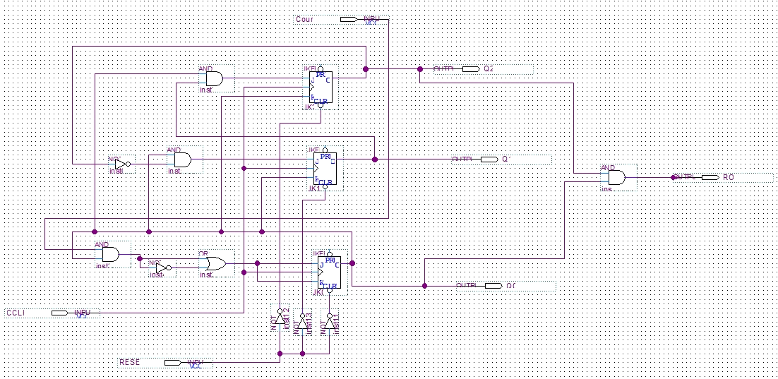

**Figure 1: modulo 6 counter schematic**

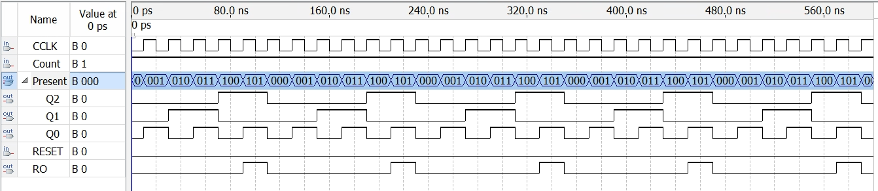

**Figure 2: modulo 6 counter waveform (counter = 1)**

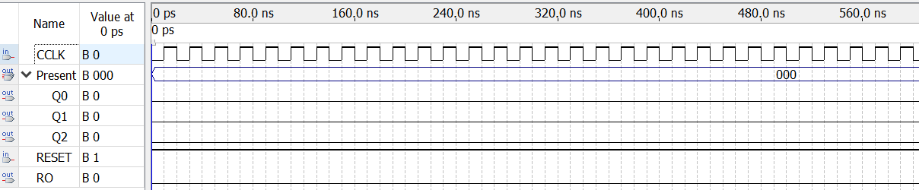

**Figure 3: modulo 6 counter waveform (counter = 0)**

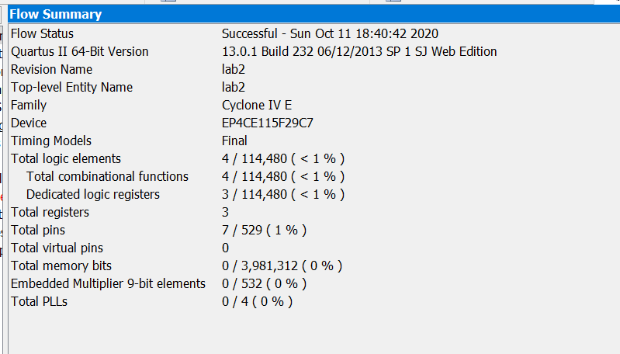

**Figure 4: modulo 6 counter Flow Summary**

**Altera Board Results for modulo 6 counter (0-5)**

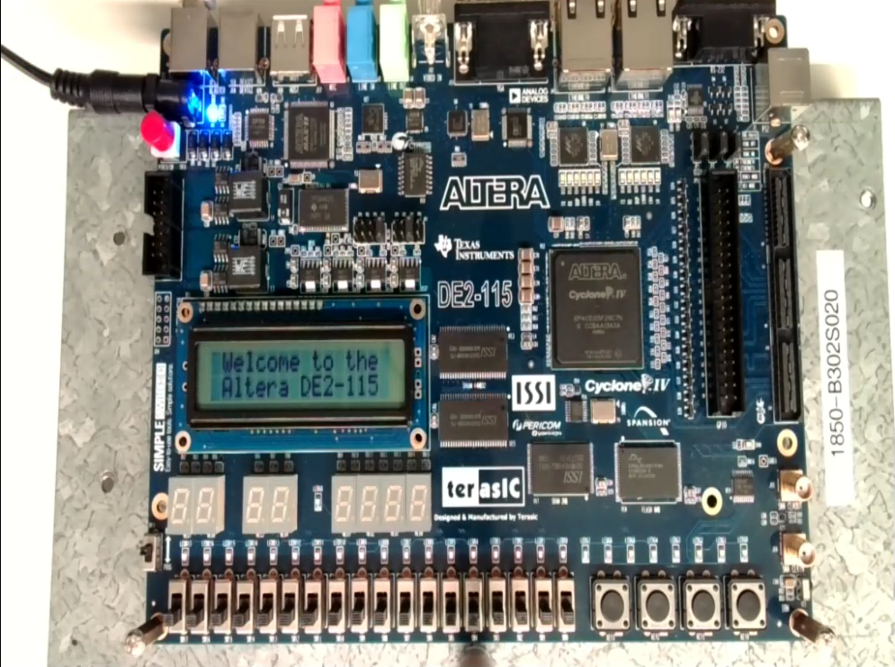

**Figure 5: Altera output 000**

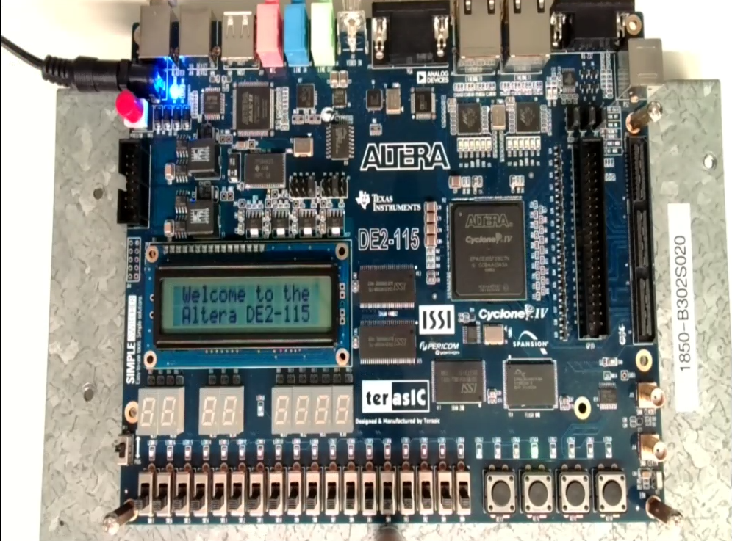

**Figure 6: Altera output 001**

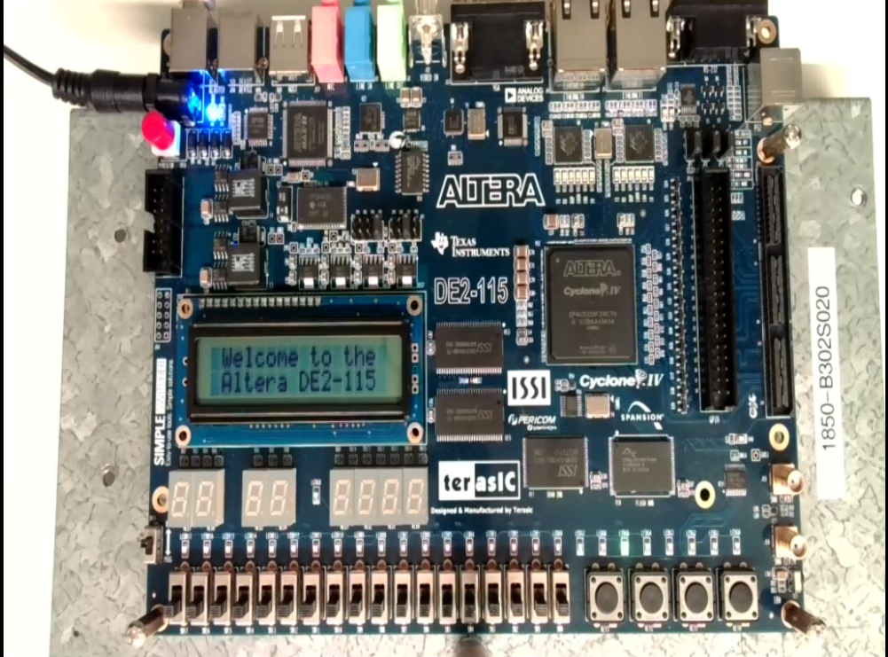

**Figure 7: Altera output 010**

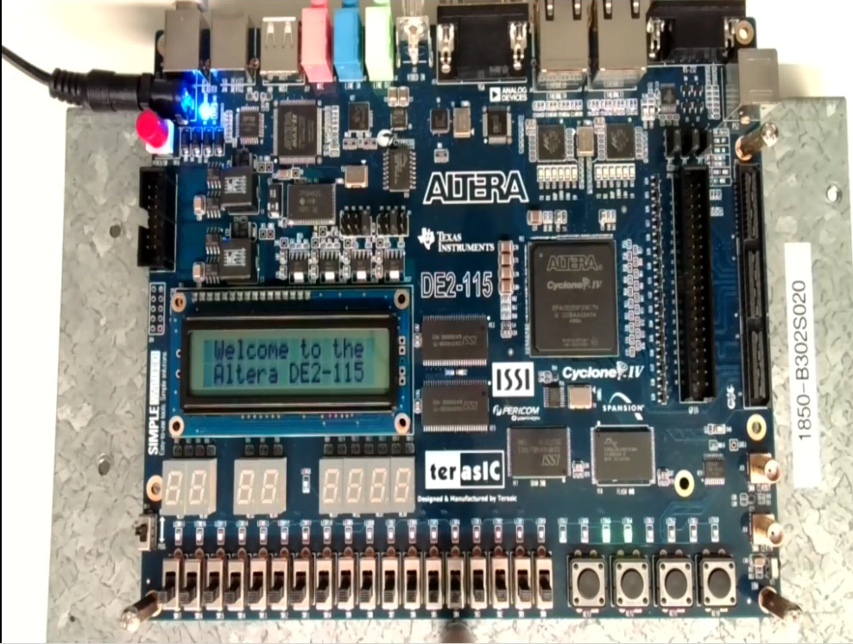

**Figure 8: Altera output 011**

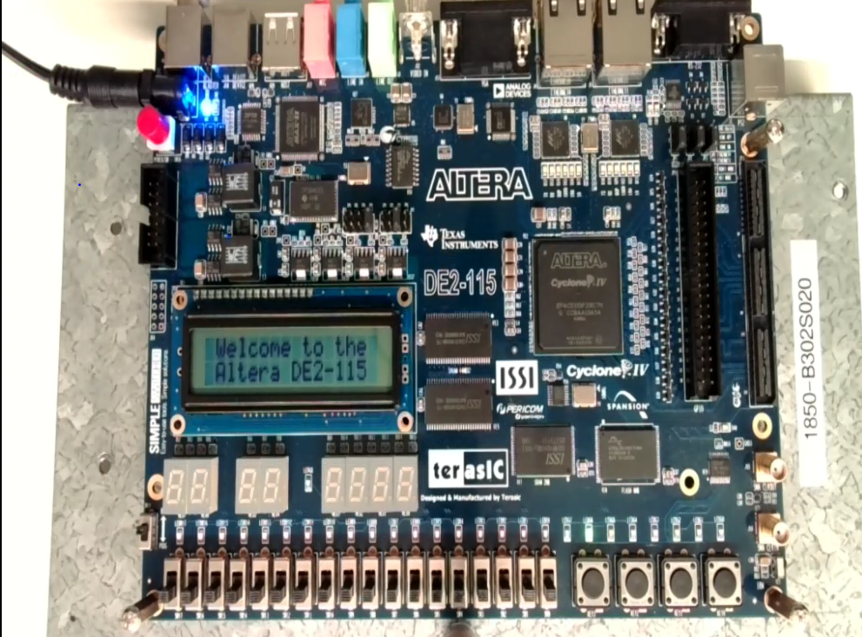

**Figure 9: Altera output 100**

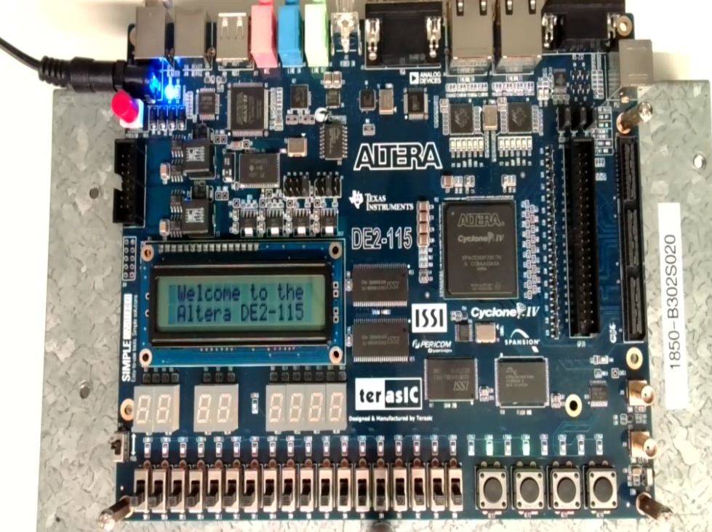

**Figure 10: Altera output 101**

**Part B**

**(4-bit synchronous BCD counter)**

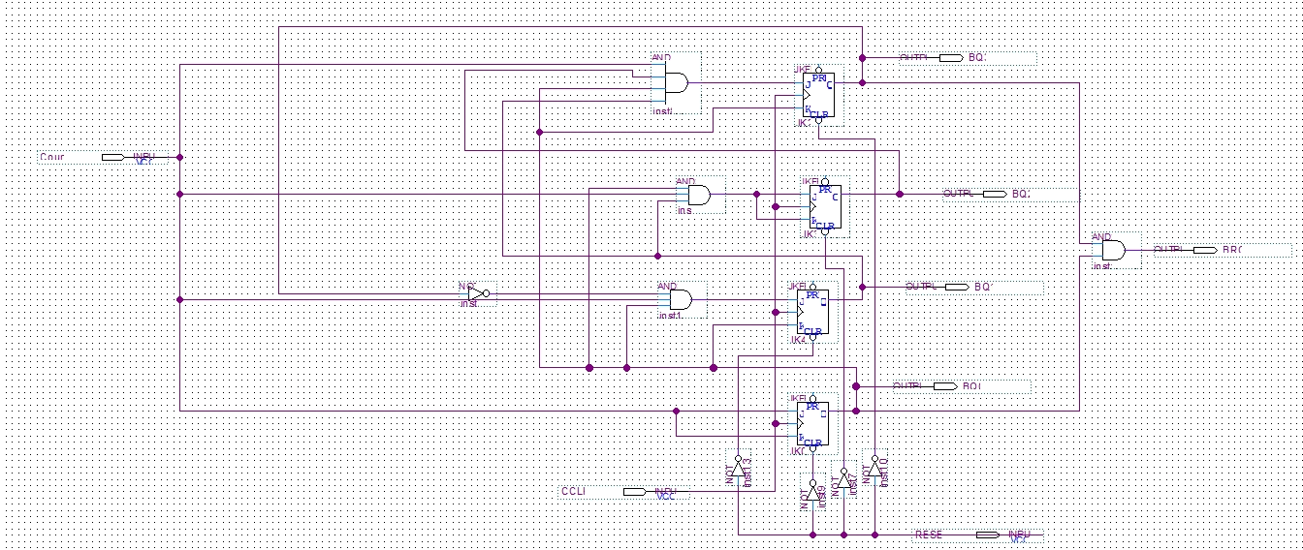

**Figure 11: BCD counter Schematic**

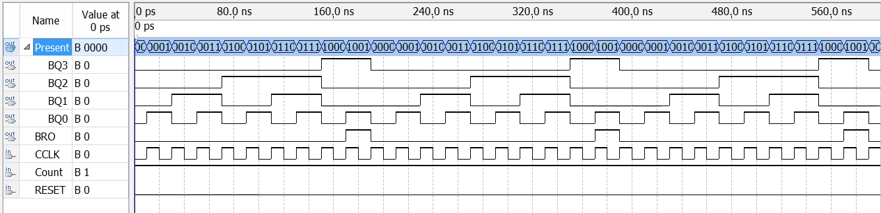

**Figure 12: BCD counter waveform (counter = 1)**

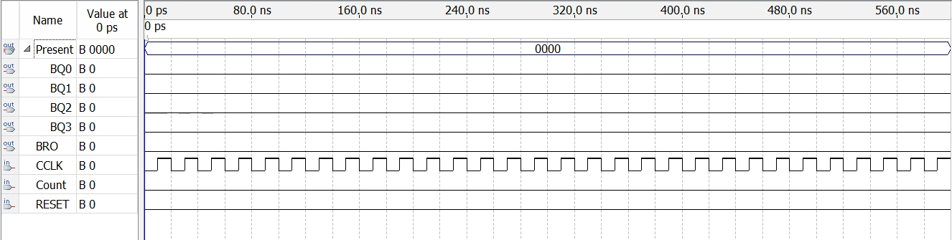

**Figure 13: BCD counter waveform (counter = 0)**

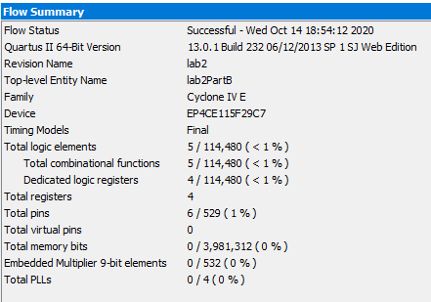

**Figure 14: BCD counter Flow Summary**

**Altera Board Results BCD Counter**

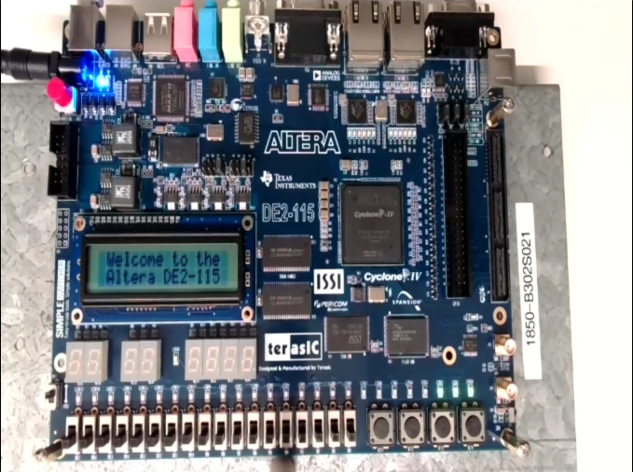

**Figure 15: Altera output 0111**

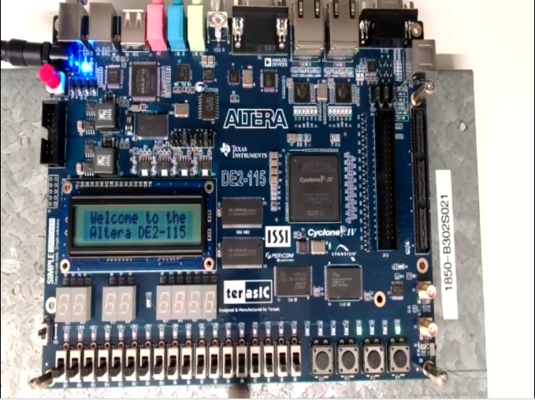

**Figure 16: Altera output 1001**

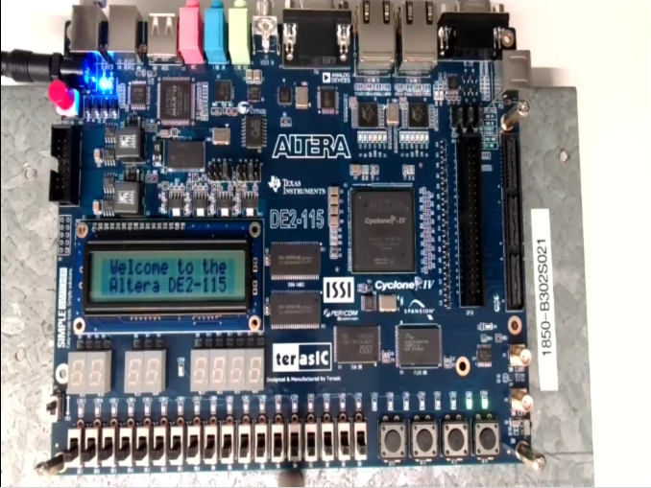

**Figure 17: Altera output 0011**

**Design Process of Solution:**

The first part of the lab required us to create a 3-bit synchronous modulo 6 counter. This was to be done with JK-flip flops. Because 3-bits is required, we must have 3 JK flip flops. Each flip flop will store either 0 or 1. This ensures that we can implement the counting sequence 000 -> 001 -> 010 -> 011 -> 100 -> 101 -> and then back to 000. The circuit also has an active low reset meaning that the flip flops will reset when the value of the reset input is 0 (driven low). This is implemented by adding NOT gates to the reset inputs. Finally, the COUNT input was implemented by using an AND gate with the inputs derived from the karnaugh maps and the COUNT input. This will ensure that when the COUNT input is 0, the inputs into the JK flip flops will also be 0 causing no change to the current state.

The second part required was to create a 4-bit synchronous BCD counter. This was also done with JK-flip flops, except this circuit required 4 of them. The Counting sequence is as follows: 0000 -> 0001 -> 0010 -> 0011 -> 0100 -> 0101 -> 0110 -> 0111 -> 1000 -> 1001 -> back to 0000. The reset and count inputs were implemented in the exact same way as part one (the mod 6 counter).

#### **Simulation and Verification Part 2.**

**Modulo 60 Counter**

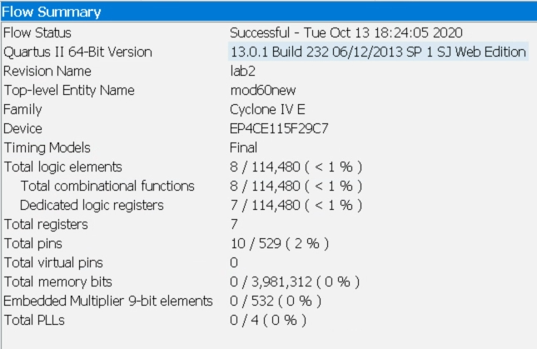

**Figure 17: Modulo 60 counter Flow summary**

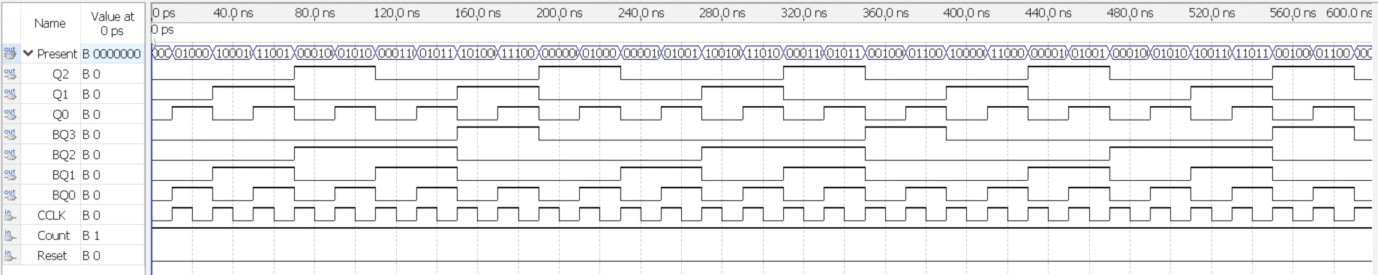

**Figure 18: Modulo 60 counter waveform**

**(far view to notice the highs and lows)**

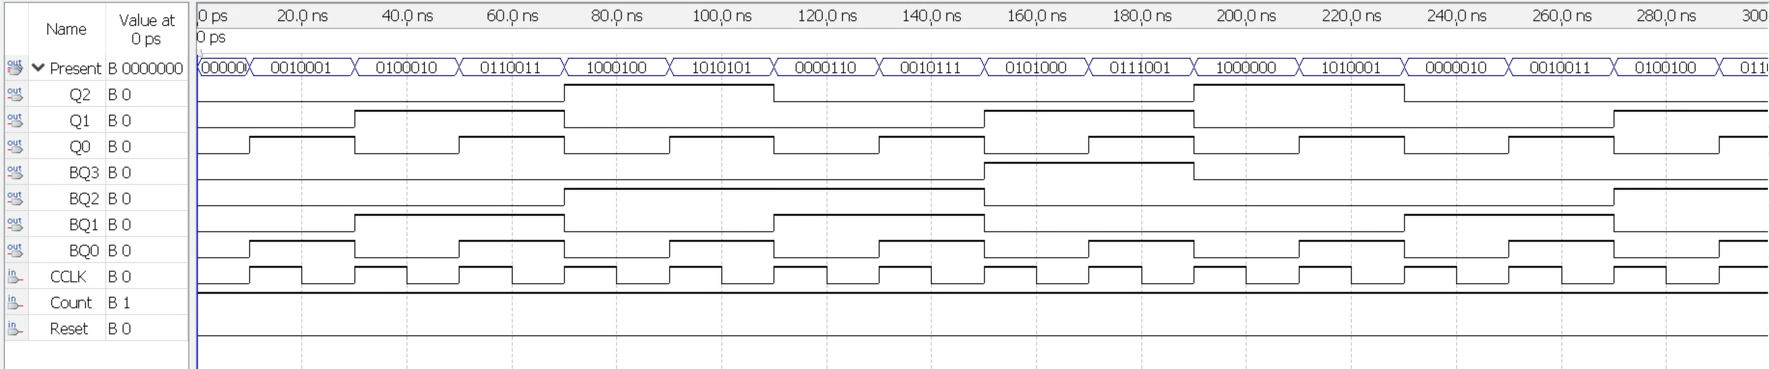

**Figure 19: Modulo 60 counter waveform**

**(close view to notice the binary combinations)**

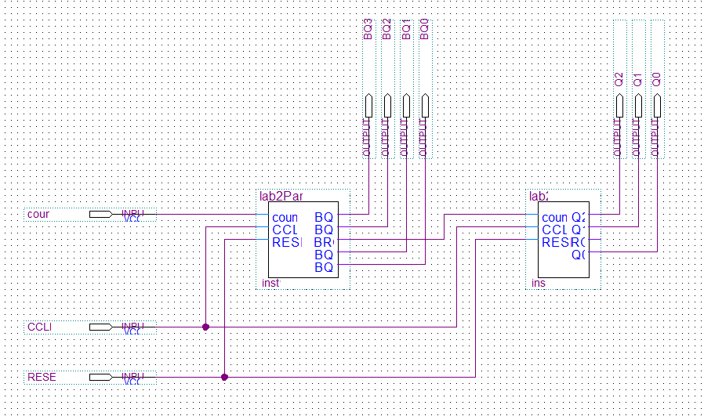

**Figure 20: Modulo 60 counter Schematic**

**Altera Board Results for Modulo 60 Counter**

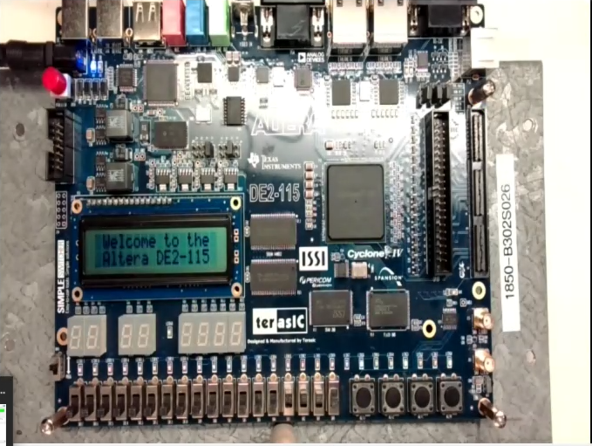

**Figure 21: Altera output 1001001**

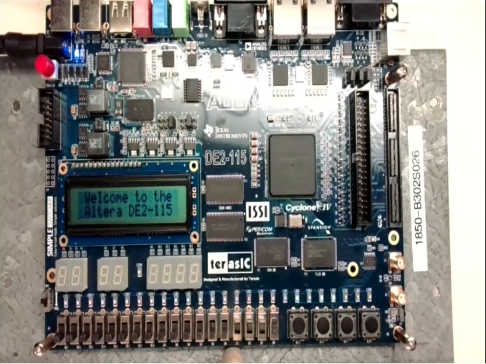

**Figure 22: Altera output 1011000**

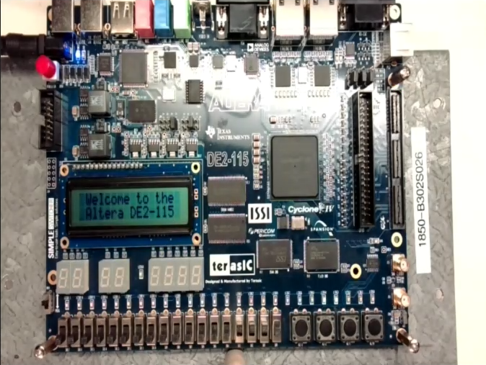

**Figure 23: Altera output 0011000**

**Design Process of Solution:**

In part 2 of the lab, we are required to implement the counting sequence from 0 to 9 and when the output is 9, we must increase the counter by one in part 1. This counter is created with JK flip flops. The bro output will only be 1 when the most significant bit and the least significant bit are both 1. This will be when the value 1001 (9) is stored in the flip flops. When the next clock cycle arrives, the part 2 value (ones’ place value) will then be 0000 and the bro output will cause the tens place value to increase by 1.

#### **Discussion**

Lab 2 consisted of using flip flops to create counters. Counters today are mainly created with flip flops. They are used mostly in devices that require storing the current state and then changing that state such as in digital clocks and time measures. In part 1 of the lab, we created a small counter that could only count from 0 to 5 and then restart again. Part 2 allowed us to combine two smaller counters together to obtain larger values and increase the amount of numbers that could be stored and outputted. The BCD counter created in part 2 allowed us to represent numbers from 0-9. This can be used as the one’s values. The 3-bit synchronous counter from part 1 allowed us to represent the tens values. Together, these two counters could represent any value between 0 - 59 in BCD format.

#### **Conclusion**

Therefore, our lab was successful because we were able to have the circuit count from 0 to 59. We have learned that multiple counters can work together simultaneously and by combining multiple counters, users can increase the range of numbers that can be stored. The BCD system is beneficial as users would not need to calculate all the flip flop combinations from the first number to the last. An example of this would be if in this lab we had to count from 0 to 59 with 1 counter, we would need 6 JK flip flops (59 = 111011) and we would need to calculate all the JK flip flop combinations between the first number to the last. Our excitation table would have 60 rows and the karnaugh maps would be quite large as well. The knowledge obtained in this lab regarding flip flops can be used in other real world applications such as the traffic light system seen in class.

#### 

#### 

#### 

#### **References**

“DE2-115 User Manual,” Terasic Technologies Inc.,http://www.terasic.com.tw/cgibin/page/archive.pl?Language=English&CategoryNo=165&No=502&PartNo=4 , 2013